REPUBLIQUE DU BENIN

**🙜🙡🖎✍🙣🙟**

MINISTERE DE L’ENSEIGNEMENT SUPERIEUR ET DE LA RECHERCHE SCIENTIFIQUE

**🙜🙡🖎✍🙣🙟**

**UNIVERSITE DE PARAKOU**

**🙜🙡🖎✍🙣🙟**

**E**COLE **N**ATIONALE DE **S**TATISTIQUE, DE **P**LANIFICATION ET DE **D**EMOGRAPHIE (**ENSPD**)

**\*\*\*\*\***

MASTER 1 SA et PSE

**\*\*\***

ECUE : Concepts et terminologies en statistique, développement local et suivi-évaluation en anglais

*

**THEME**

**Representation in statistics**

|  |  |
| --- | --- |
| *Membres du Groupe 9 et 20* |  |
| HOUNGBODJI Mark Syr Franck |  |
| KINSA Foubo Ulrich |  |
| HODABALO Aklésso Jean- Baptiste | *Sous la direction de l’Enseignant* |
| OROU BODEDJO Goudi | Dr. M’PO K. N. Béatrice |
| AZOMAN Wilfred Eustache |  |
| TOSSA Valentin |  |
| OUENDO Austella Carline Abissola |  |
| HODJIGUE Kossi |  |
| YOUSSOUF Tawaye |  |

**Introduction**

Representation in statistics is the foundation of effectively communicating data insights and findings. It involves the use of various tools and techniques to summarize, analyze, and visualize data in ways that make patterns, relationships, and trends clear and interpretable. The goal of representation is to transform raw data into meaningful information that can guide decision-making, problem-solving, and further research.

In statistics, data comes in diverse forms—ranging from numerical values to categorical classifications, time-series data, and even geospatial information. To make sense of these complexities, statisticians and researchers rely on different methods of representation, including tabular formats, graphical visuals, numerical summaries, and textual explanations. Each form of representation serves a specific purpose, whether it is to simplify large datasets, identify correlations, or highlight variations.

Effective representation is not only about accuracy but also about accessibility. It bridges the gap between technical statistical analysis and its practical application in fields such as health, economics, social sciences, and technology. For instance, a bar chart can quickly convey sales performance, while a regression model can explain the relationship between income and education level.

In this introduction to the topic, we will explore the key forms of representation in statistics, their purposes, and how they contribute to making data understandable and actionable for a wide range of audiences. Whether you are a student, researcher, or professional, understanding statistical representation is crucial for drawing meaningful conclusions from data.

1. **Definition of representation in statistic**

Representation of data in statistics is the process of organizing information about a group or sample. This helps researchers better understand their data and find patterns within it that would not be apparent without visualizing them firsthand! The most common types are line graphs, bar charts, pie charts, histograms, and scatter plots. These will all show different aspects of your data in different ways, so it’s important to choose wisely!

1. **Type of representation in statistic**
   1. **Graphical Representation of data in statistics**

Graphical representation of data in statistics is a way to communicate information visually. Graphs are used to show relationships between two or more variables, which can then be analyzed, and conclusions are drawn. Graphical representations of data are often used in newspapers and research papers to present large amounts of complex data quickly and clearly.

* + 1. **Type of graphs in statistics**

There are various types of graphs used for the statistical representation of data. These include line charts, bar charts, pie charts, etc., but all these have their specific applications only. In this blog post, we will discuss the different types of graphs and how to use them effectively!

* **Line charts**

A line graph is a graphical representation of data, where the points on the Cartesian plane are connected by lines. The value of each coordinate point determines its position along an axis or scale, while it can be plotted as either linear (straight) or curved segments. A new plot must be added to the existing graph in order to plot a new line on it.

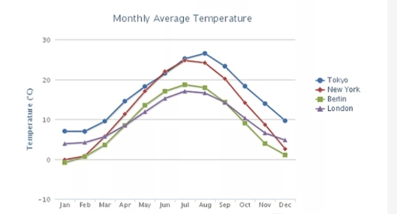

* **Bar graphs**

A bar graph is used for categorical data and shows comparisons among categories or variables. A bar chart can have vertical bars, horizontal bars, and stacked bars which are used either horizontally or vertically. The length of the bar represents its size.

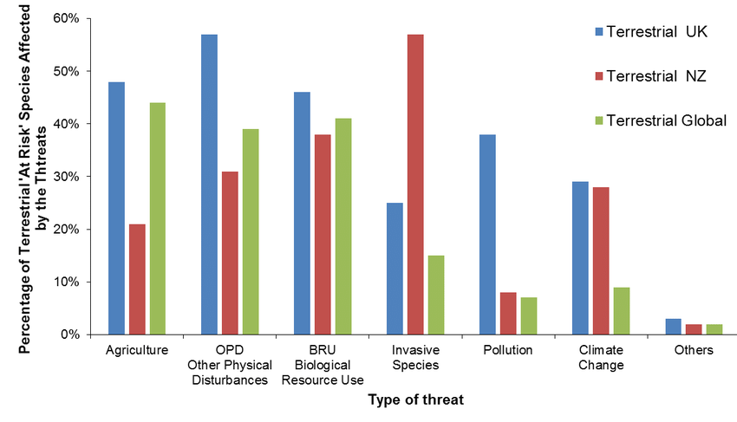

* **Pie charts**

A pie chart is used for categorical data and shows the proportions of a whole divided into segments. The arc length of each sector (slice) is proportional to the size of its representing value.

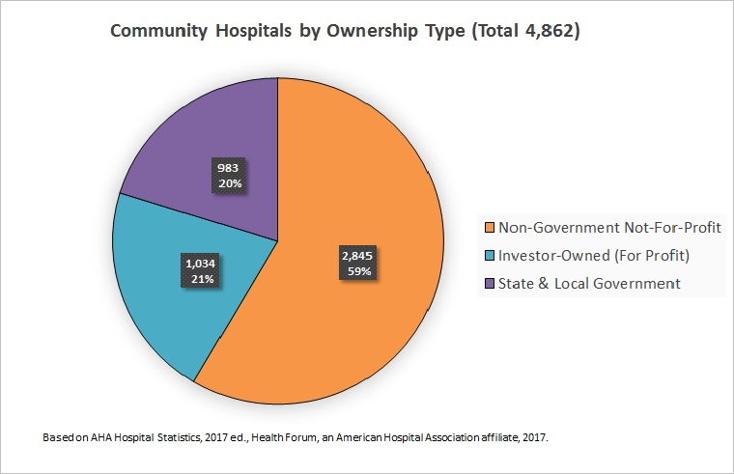

* **XY graphs**

An XY graph is used for numerical data and plots points in two dimensions. It uses an x-axis and y-axis to measure values. The x-axis and y-axis intersect at zero.

* **Histograms**

A histogram is used for numerical data and shows the distribution of a dataset by grouping it into bins across the range of values. A bar graph is used to show comparisons between different categories or groups, but it does not represent changes over time.

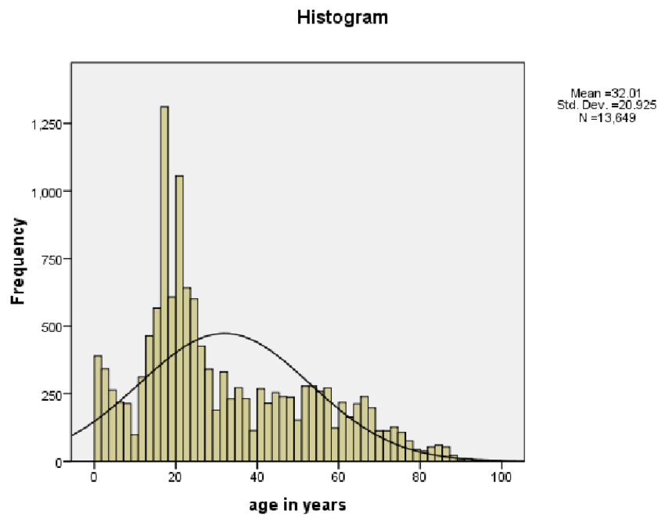

* 1. **Tabular representations**

Tabular representations organize data in the form of tables, allowing for easy reading and comparison of information. They are particularly useful for representing quantitative or qualitative data and for performing precise calculations. The most significant benefit of tabulation is that it coordinates data for additional statistical treatment and decision making. The analysis used in tabulation is of four types:

1. **Simple Tabulation :** Presents data based on a single variable. For example, a table showing the number of farmers adopting a particular agricultural technique.
2. **Double Tabulation :** Organizes data based on two variables. For example, a table showing the number of farmers according to the adopted agricultural technique and their region.
3. **Multiple Tabulation :** Involves multiple variables at the same time. For example, a table showing the number of farmers based on the agricultural technique, region, and soil type.
4. **Complex Tabulation :** Used for more in-depth analysis, it involves subdivisions and more detailed classifications, such as the interaction between several factors influencing the adoption of an agricultural technology.

**Conclusion**

Representation in statistics is vital for transforming data into meaningful insights. By using tables, graphs, numerical summaries, and textual explanations, it simplifies complex datasets, highlights patterns, and communicates findings effectively. The choice of representation depends on the data type, audience, and purpose, ensuring clarity and accessibility. Effective representation bridges the gap between analysis and practical application, enabling informed decisions in fields like health, economics, and social sciences. As data continues to shape our world, mastering statistical representation ensures insights are understood and actionable, empowering researchers and organizations to drive progress and solve real-world problems effectively.